|  |
| --- |
| Mathematical and UML Diagrams |

|  |
| --- |
| Stephen Adu, Jens Domela Nieuwenhuis and Andrej Cholodov  12-12-2016 |

Contents

1. Use case 2

1.1 Use case description 2

1.2 Use case diagram 2

2. UML Diagrams 3

2.1 Domain Diagram 3

2.2 Sequence Diagram 4

3. Mathematical Models 4

3.1 Competitive Lotka-Volterra Equation 4

3.2 Competition Coefficient 5

# Use case

## 1.1 Use case description

**Primary actor:** user/client

**Stakeholder and Interests:**

* **User:** interested in prediction
* **Group 1:** wants to know the workout for the grass

**Precondition:**

**Post-condition:**

**Main Success:**

1. User opens the application.
2. System asks for parameters.
3. User enters variables.
4. System validates variables.
5. System processes variables in the formula.
6. System shows results.
7. System sends results to the other application.
8. User closes the program.

## 1.2 Use case diagram

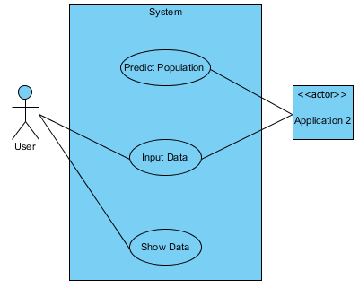

# UML Diagrams

## 2.1 Domain Diagram

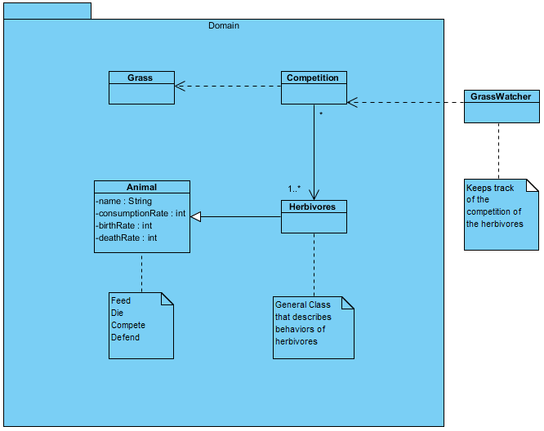

## 2.2 Sequence Diagram

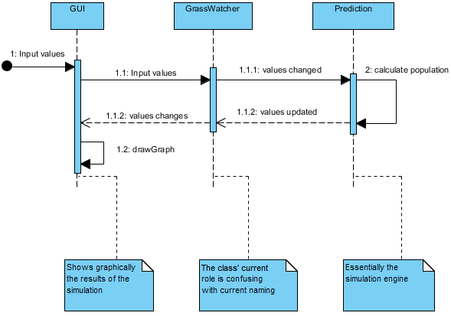

# Mathematical Models

## 3.1 Competitive Lotka-Volterra Equation

$$\frac{{dx}_{i}}{dt}=r_{i}x_{i}(1-\frac{\sum_{j=1}^{N}{a_{ij}x_{j}}}{K_{i}})$$

Calculation of the effect of competing species on the growth of species *i*. (Schoener,1974)

* $\frac{{dx}_{i}}{dt}$ refers to the population growth rate of species *i*.
* $r_{i}$ refers to the intrinsic rate of increase of species *i*.
* $x_{i}$ refers to the population of species *i*.
* $N$ refers to the total amount of competing species.
* $K_{i}$ refers to the carrying capacity of species *i*.
* $a_{ij}$ refers to the competition coefficient of species *j* upon *i*.

Note that $a_{ii}$ is equal to 1.

## 3.2 Competition Coefficient

$$a_{ij}= \frac{\sum_{h}{p_{ih}}p_{jh}}{\sum_{h}{{p_{ih}}^{2}}}$$

Calculation of the competition of species *j* on species *i*. (Gotelli,2008)

* $a_{ij}$ is the competition coefficient
* $p_{ih}$ refers to the relative utilization of resource *h* by species *i*, computed as a fraction of the total utilization of all resources for species *i*.

**References**:

Schoener, T. (1974). Some Methods for Calculating Competition Coefficients from Resource-Utilization Spectra. *The American Naturalist,* *108*(961), 332-340. Retrieved from <http://www.jstor.org/stable/2459895>

Gotelli, Nicholas J. (2008). *A Primer of Ecology.* Sunderland, MA: Sinauer.